1. **INTRODUCTION**
   1. *overview*
      * *Description of the project*

Project Description:

Fashion hevan is a private limilted company also registered under GST in tamilnadu . fashion hevan is a rertailer of various lifestyle products in wholesale and retail , it has a wide range of customers (B2B&B2C) all over the state and it process from various suppliers in the state. it operates at a groos profit margin of 50%.

PURPOSE:

Fashion haven an online retail store , leverages zoho books to manage their inventory and track sales. they

can generate invoices and manage customer payment seamless .zoho books also enables them to reconcile

bank transactions and financial report ,helping them make informed decision about their business..

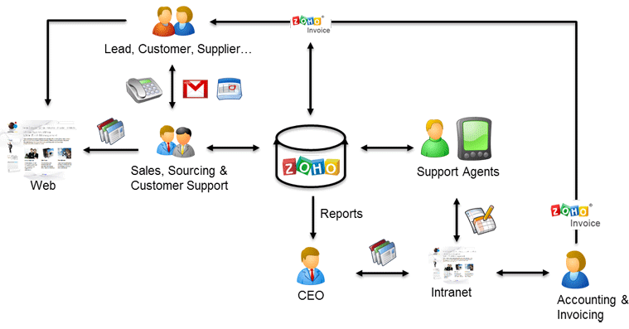

As a Center of Excellence, HealthHub Clinics offers multi-disciplinary resources and smart healthcare solutions, supported by a holistic and compassionate approach, understanding and quality care designed around your health.

1. **Problem definition & design Thinking**
   1. *Empathy map*

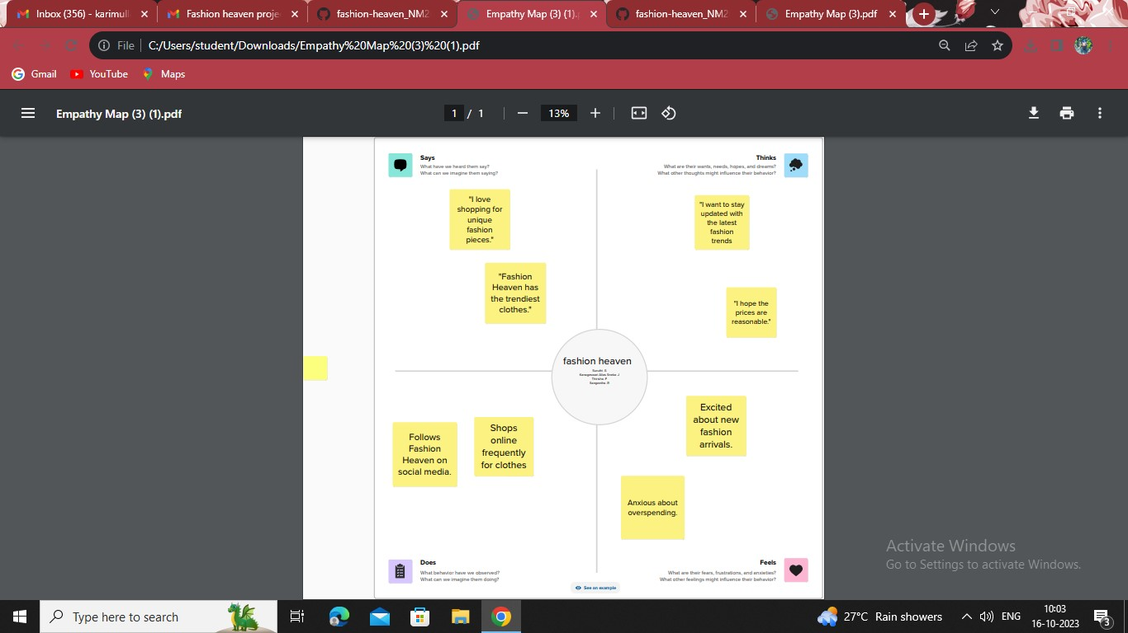

* 1. *Ideation & Brainstorming map*

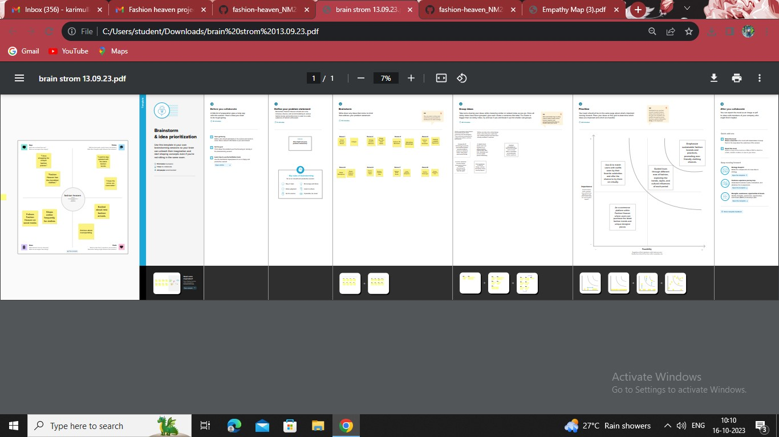

1. **Result Profit&loss**

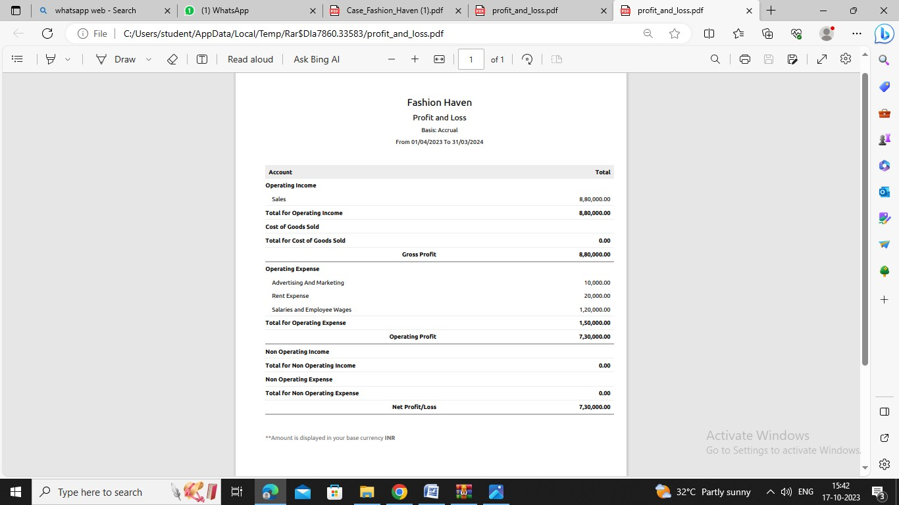

Balance sheet:

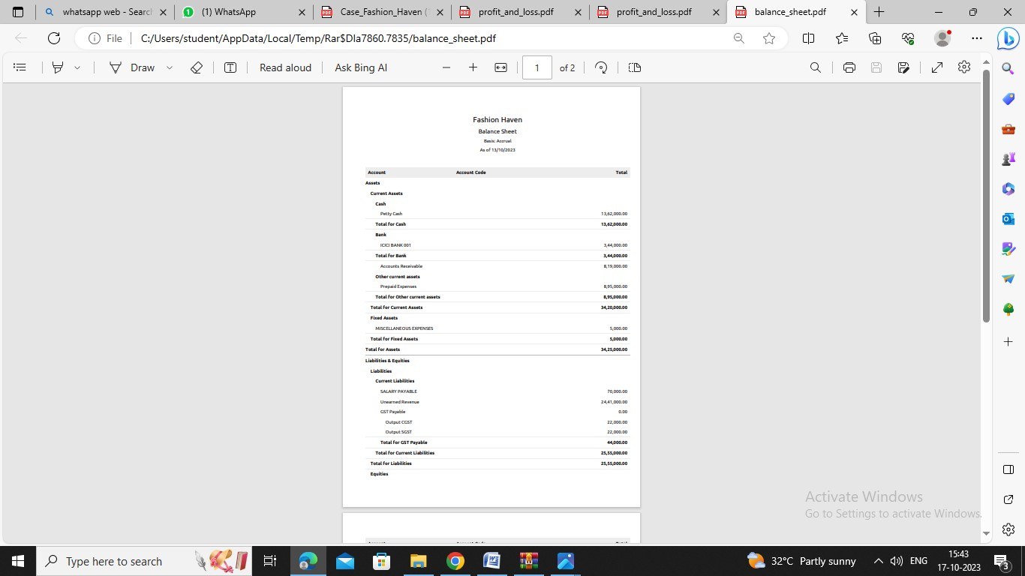

Purchase order:

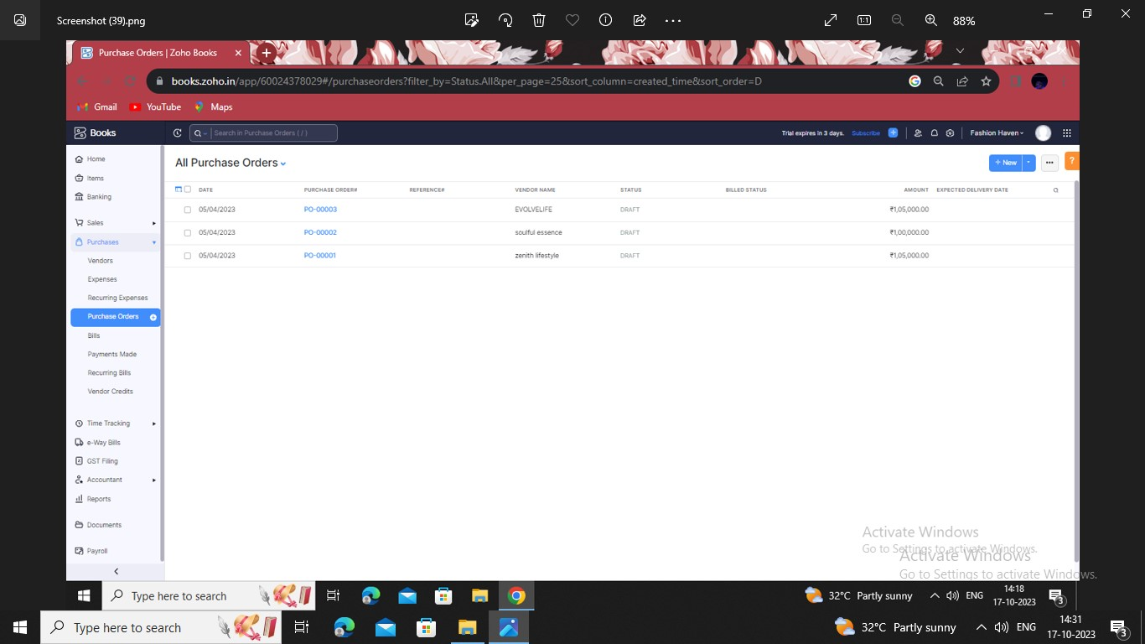

ADVANTANGES OF FASHION HEVAN:

1. Invoicing and billing
2. expense tracking
3. minimixe data lost
4. Report generation
5. inventory management

DISADVANTAGES OF HEALTHHUB MEDICAL CLINIC:

1. Difficult to modify invoice
2. Maximum of 10 users
3. Time Tracking must be tied to project
4. limited bank syncing
5. Difficult to modify bills

5.APPLICATION:

FASHION HAVEN

**6.Conclusion:**

The zoho books are usefull to maintain ,record, summarize and analysis accounting entries made in this cloud based software .we need any manual record to maintain the accounts .we can prepare the bill and maintain accounts in one software.

1. **FUTURE SCOPE:**

* IT best software to maintain accounts and for billing ,so we need
* There is need not any accounts to record the transactions .
* This will be used by most company to maintain accounts in their company.
* Reduce the time to maintain accounts.

1. **APPENDIX:**

<https://github.com/suruthimanoj/fashion-heaven_NM2023TMID23175/edit/main/README.md>

|  |  |  |  |  |  |  |  |  |  |  |  |  |  |  |  |  |  |  |  |  |  |  |  |  |  |  |  |  |  |  |  |  |  |  |  |  |  |  |  |  |  |  |  |  |  |  |  |  |  |  |  |  |  |  |  |  |  |  |  |  |  |  |  |  |  |  |  |  |  |  |  |  |  |  |  |  |  |  |  |  |  |  |  |  |  |  |  |  |  |  |  |  |  |  |  |  |  |  |  |  |  |  |  |  |  |  |  |  |  |  |  |  |  |  |  |  |  |  |  |  |  |  |  |  |  |  |  |  |  |  |  |  |  |  |  |  |  |  |  |  |  |  |  |  |  |  |  |  |  |  |  |  |  |  |  |  |  |  |  |  |  |  |  |  |  |  |  |  |  |  |  |  |  |  |  |  |  |  |  |  |  |  |  |  |  |  |  |  |  |  |  |  |  |  |  |  |  |  |  |  |  |  |  |  |  |  |  |  |  |  |  |  |  |  |  |  |  |  |  |  |  |  |  |  |  |  |  |  |  |  |  |  |  |  |  |  |  |  |  |  |  |  |  |  |  |  |
| --- | --- | --- | --- | --- | --- | --- | --- | --- | --- | --- | --- | --- | --- | --- | --- | --- | --- | --- | --- | --- | --- | --- | --- | --- | --- | --- | --- | --- | --- | --- | --- | --- | --- | --- | --- | --- | --- | --- | --- | --- | --- | --- | --- | --- | --- | --- | --- | --- | --- | --- | --- | --- | --- | --- | --- | --- | --- | --- | --- | --- | --- | --- | --- | --- | --- | --- | --- | --- | --- | --- | --- | --- | --- | --- | --- | --- | --- | --- | --- | --- | --- | --- | --- | --- | --- | --- | --- | --- | --- | --- | --- | --- | --- | --- | --- | --- | --- | --- | --- | --- | --- | --- | --- | --- | --- | --- | --- | --- | --- | --- | --- | --- | --- | --- | --- | --- | --- | --- | --- | --- | --- | --- | --- | --- | --- | --- | --- | --- | --- | --- | --- | --- | --- | --- | --- | --- | --- | --- | --- | --- | --- | --- | --- | --- | --- | --- | --- | --- | --- | --- | --- | --- | --- | --- | --- | --- | --- | --- | --- | --- | --- | --- | --- | --- | --- | --- | --- | --- | --- | --- | --- | --- | --- | --- | --- | --- | --- | --- | --- | --- | --- | --- | --- | --- | --- | --- | --- | --- | --- | --- | --- | --- | --- | --- | --- | --- | --- | --- | --- | --- | --- | --- | --- | --- | --- | --- | --- | --- | --- | --- | --- | --- | --- | --- | --- | --- | --- | --- | --- | --- | --- | --- | --- | --- | --- | --- | --- | --- | --- | --- | --- | --- | --- | --- | --- | --- | --- | --- | --- | --- | --- | --- | --- | --- | --- | --- |
| <html lang="en" data-color-mode="auto" data-light-theme="light" data-dark-theme="dark" data-a11y-animated-images="system" data-a11y-link-underlines="false">   |  |  | | --- | --- | |  | <style> | |  | /* for each iteration, uncomment the CSS variable */ | |  |  | |  | /* light themes */ | |  | [data-color-mode="light"][data-light-theme*="light"], | |  | [data-color-mode="auto"][data-light-theme*="light"] { | |  | /* iteration 1 */ | |  | --border-color-iteration-1: #C8CCD0; | |  | /* iteration 2 */ | |  | --border-color-iteration-2: #BABFC5; | |  | /* iteration 3 */ | |  | --border-color-iteration-3: #A6ADB4; | |  | /* iteration final */ | |  | --border-color-iteration-4: #868F99; | |  |  | |  | /* the first value is the final step, which falls back to previous iterations */ | |  | --control-borderColor-rest: var(--border-color-iteration-4, var(--border-color-iteration-3, var(--border-color-iteration-2, var(--border-color-iteration-1)))) !important; | |  | } | |  |  | |  | /* dark themes */ | |  | [data-color-mode="dark"][data-dark-theme*="dark"], | |  | [data-color-mode="auto"][data-light-theme*="dark"] { | |  | /* iteration 1 */ | |  | --border-color-iteration-1: #363940; | |  | /* iteration 2 */ | |  | --border-color-iteration-2: #3F434B; | |  | /* iteration 3 */ | |  | --border-color-iteration-3: #4B5159; | |  | /* iteration final */ | |  | --border-color-iteration-4: #666E79; | |  |  | |  | /* the first value is the final step, which falls back to previous iterations */ | |  | --control-borderColor-rest: var(--border-color-iteration-4, var(--border-color-iteration-3, var(--border-color-iteration-2, var(--border-color-iteration-1)))) !important; | |  | } | |  |  | |  | [data-color-mode="dark"][data-dark-theme="dark_dimmed"], | |  | [data-color-mode="dark"][data-dark-theme="light_high_contrast"], | |  | [data-color-mode="dark"][data-dark-theme="dark_high_contrast"], | |  | [data-color-mode="light"][data-light-theme="dark_dimmed"], | |  | [data-color-mode="light"][data-light-theme="light_high_contrast"], | |  | [data-color-mode="light"][data-light-theme="dark_high_contrast"] { | |  | /* skip these themes, use the fallback */ | |  | --control-borderColor-rest: initial !important; | |  | } | |  |  | |  | @media (prefers-color-scheme: dark) { | |  | /* dark colors in dark mode */ | |  | [data-color-mode="auto"][data-dark-theme*="dark"] { | |  | /* iteration 1 */ | |  | --border-color-iteration-1: #363940; | |  | /* iteration 2 */ | |  | --border-color-iteration-2: #3F434B; | |  | /* iteration 3 */ | |  | --border-color-iteration-3: #4B5159; | |  | /* iteration final */ | |  | --border-color-iteration-4: #666E79; | |  |  | |  | /* the first value is the final step, which falls back to previous iterations */ | |  | --control-borderColor-rest: var(--border-color-iteration-4, var(--border-color-iteration-3, var(--border-color-iteration-2, var(--border-color-iteration-1)))) !important; | |  | } | |  |  | |  | /* light colors in dark mode */ | |  | [data-color-mode="auto"][data-dark-theme*="light"] { | |  | /* iteration 1 */ | |  | --border-color-iteration-1: #C8CCD0; | |  | /* iteration 2 */ | |  | --border-color-iteration-2: #BABFC5; | |  | /* iteration 3 */ | |  | --border-color-iteration-3: #A6ADB4; | |  | /* iteration final */ | |  | --border-color-iteration-4: #868F99; | |  |  | |  | /* the first value is the final step, which falls back to previous iterations */ | |  | --control-borderColor-rest: var(--border-color-iteration-4, var(--border-color-iteration-3, var(--border-color-iteration-2, var(--border-color-iteration-1)))) !important; | |  | } | |  |  | |  | [data-color-mode="auto"][data-dark-theme="dark_dimmed"], | |  | [data-color-mode="auto"][data-dark-theme="light_high_contrast"], | |  | [data-color-mode="auto"][data-dark-theme="dark_high_contrast"] { | |  | /* skip these themes, use the fallback */ | |  | --control-borderColor-rest: initial !important; | |  | } | |  | } | |  |  | |  | @media (prefers-color-scheme: light) { | |  | /* dark colors in light mode */ | |  | [data-color-mode="auto"][data-light-theme*="dark"] { | |  | /* iteration 1 */ | |  | --border-color-iteration-1: #363940; | |  | /* iteration 2 */ | |  | --border-color-iteration-2: #3F434B; | |  | /* iteration 3 */ | |  | --border-color-iteration-3: #4B5159; | |  | /* iteration final */ | |  | --border-color-iteration-4: #666E79; | |  |  | |  | /* the first value is the final step, which falls back to previous iterations */ | |  | --control-borderColor-rest: var(--border-color-iteration-4, var(--border-color-iteration-3, var(--border-color-iteration-2, var(--border-color-iteration-1)))) !important; | |  | } | |  |  | |  | /* light colors in light mode */ | |  | [data-color-mode="auto"][data-light-theme*="light"] { | |  | /* iteration 1 */ | |  | --border-color-iteration-1: #C8CCD0; | |  | /* iteration 2 */ | |  | --border-color-iteration-2: #BABFC5; | |  | /* iteration 3 */ | |  | --border-color-iteration-3: #A6ADB4; | |  | /* iteration final */ | |  | --border-color-iteration-4: #868F99; | |  |  | |  | /* the first value is the final step, which falls back to previous iterations */ | |  | --control-borderColor-rest: var(--border-color-iteration-4, var(--border-color-iteration-3, var(--border-color-iteration-2, var(--border-color-iteration-1)))) !important; | |  | } | |  |  | |  | [data-color-mode="auto"][data-light-theme="dark_dimmed"], | |  | [data-color-mode="auto"][data-light-theme="light_high_contrast"], | |  | [data-color-mode="auto"][data-light-theme="dark_high_contrast"] { | |  | /* skip these themes, use the fallback */ | |  | --control-borderColor-rest: initial !important; | |  | } | |  | } | |  | </style> | |
|  |  |